4th Annual
Christopher Urban
& Brittney Walsh
Memorial Track & Field Invitational
Tuesday May 13, 2014


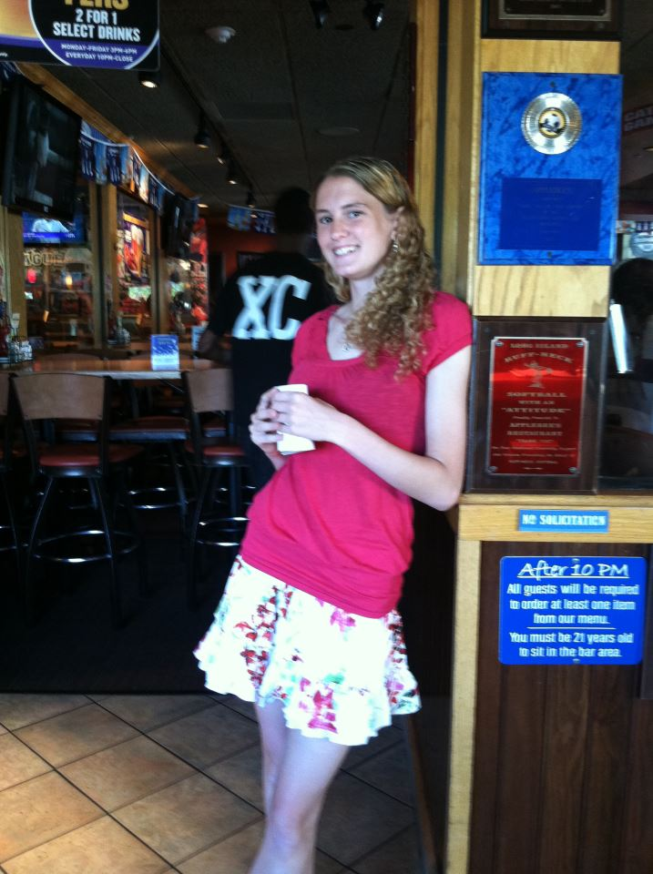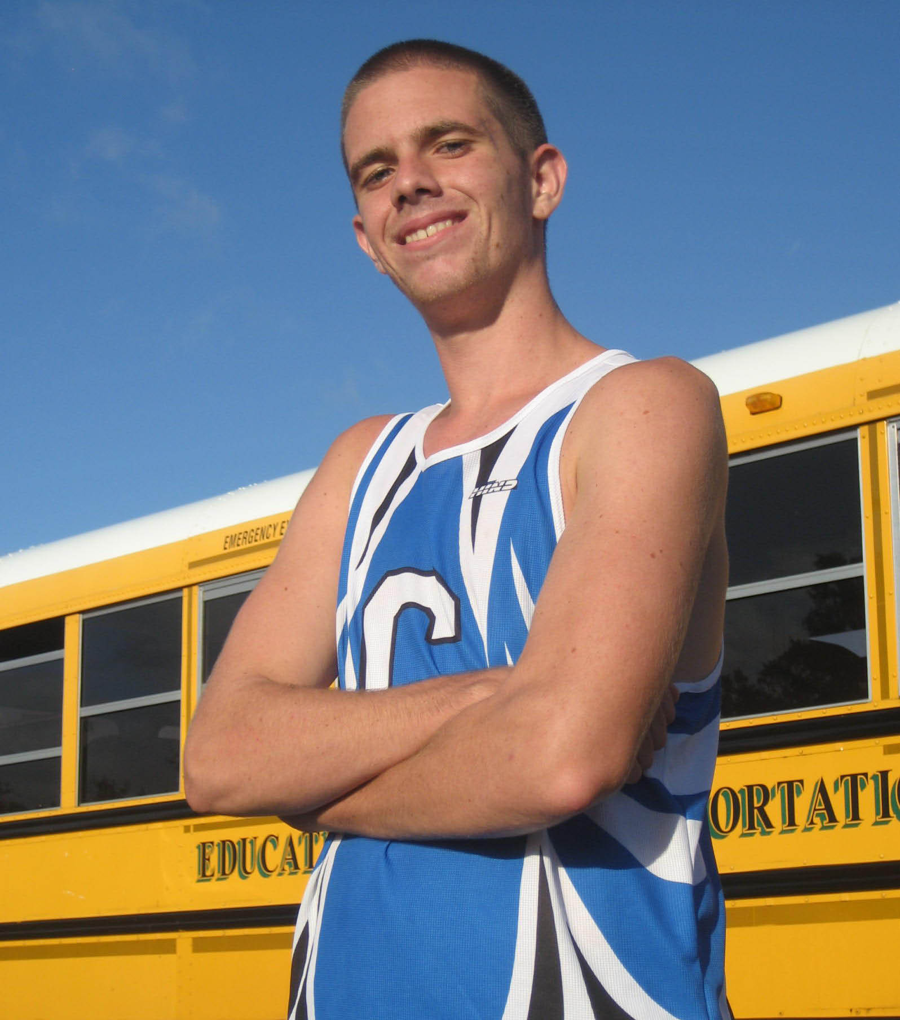

Walter G. O’Connell-Copiague HS
Copiague High School’s
4th Annual Urban & Walsh Memorial Invitational
In honor & memorial of Christopher Urban & Brittney Walsh
Tuesday, May 13, 2014

Copiague High School---1100 Dixon Avenue---Copiague, NY

Clerking: Begins at 3:30pm
- This meet is open to all HS boys and girls.
- Athletes may compete in any three (3) events.
- Limit of two teams per school in each of the relays.
- There will not be any separate Frosh/Soph events.
- Please use stickers for all events (event, name, school, grade)

Awards:
- Medals will be given to the top three finishers in all events, with a distinctive 1st place

Spikes:
- ¼ in maximum length can be worn on all runways and the track.

Food:
- Hot BBQ & cold food and drinks will be on sale the day of the meet, as well as Invite T-shirts.
Please support the Copiague Booster Club.

Entry Fees:
- Section XI teams: $125.00 blanket fee, or $10.00 per individual & $20.00 per relay
  - Boys & Girls combined: $200.00
- Non-Section XI teams: $150.00 blanket fee, or $10.00 per individual & $20.00 per relay
  - Boys & Girls combined: $250.00

WE’VE KEPT OUR ENTRY FEE LOW TO REFLECT FISCAL RESTRAINT.

- Blanket Fee: allows for unlimited individual entries.
- Meet will be limited to the first 25 teams with paid entry!
  - 2013 had 24 teams competing!!!

Copiague High School’s
4th Annual Urban & Walsh Memorial Invitational
In honor & memorial of Christopher Urban & Brittney Walsh
Tuesday, May 13, 2014

“Most people run a race to see who is fastest. I run a race to see who has the most guts.”
---Steve Prefontaine

ORDER OF EVENTS
RUNNING EVENTS START AT 4:00 PM
- Girls Events Followed by Boys (except hurdle finals)
- Verbal seeds for all running events
- ALL ATHLETES MUST HAVE A COMPETITOR NUMBER!!!

- 2000/3000 Steeplechase
- 100/110 HH (semis)
- 1500/1600-Chris Urban Memorial Event
- 110/100 HH (finals)--- boys final 1st
- 100 (semis)
- 400
- Copiague Elementary School 4 x 100
- 100 (finals)
- 800
- 400IH
- 200 (finals on time)
- 4 x 800
- 4 x 400
- TEXAS SPRINT RELAY (100-100-200-400)

FIELD EVENTS START AT 4:00PM
  - Seed cards will be used for all field events
  - There will be NO triple jump
- ALL ATHLETES MUST HAVE A COMPETITOR NUMBER!!!

- GIRLS SHOT FOLLOWED BY BOYS---top 6 to finals
- BOYS DISCUS FOLLOWED BY GIRLS---top 6 to finals
- BOYS LJ FOLLOWED BY GIRLS LJ---top 6 to finals
- GIRLS HIGH JUMP FOLLOWED BY BOYS

Copiague High School’s
4th Annual Urban & Walsh Memorial Invitational
In honor & memorial of Christopher Urban & Brittney Walsh
Tuesday, May 13, 2014

Entries Due: May 5th, 2014
Entries received after may be denied entry.
Meet will be limited to the first 25 teams with paid entry!

School: ___________________________________ _ (circle one) BOYS GIRLS

Coach’s Name: _______ ___________________________________________

Coaches Email: _____________________________________________ ____

School Phone # (____) _________________ Coach’s Phone # (____) __________________

Approximate # of overall athletes attending: _________
Entry Fees:
- Please circle one Section XI team OR Non-Section XI team
If using blanket fee: $125.00 $150.00

Combined Teams OR Combined Teams
$200.00 $250.00 OR

- # of individuals ___________ X $10.00 each = ____________

- # of relays _______________ X $20.00 each = ____________

      - TOTAL AMOUNT DUE = ____________

This is an entry fee not a participation fee & the meet will be capped at 25 teams.

Make checks or PO’s payable to Copiague High School and send to:

COPIAGUE H.S.---c/o George Schroeder---1100 Dixon Avenue---Copiague, New York 11726
Questions---Comments---Concerns
Contact---George Schroeder email at gschroeder@copiague.net or call 516-672-4086 (cell)

“The will to win means nothing if you haven't the will to prepare”
---Juma Ikangaa, 1989 NYC Marathon winner
Copiague High School’s
4th Annual Urban & Walsh Memorial Invitational

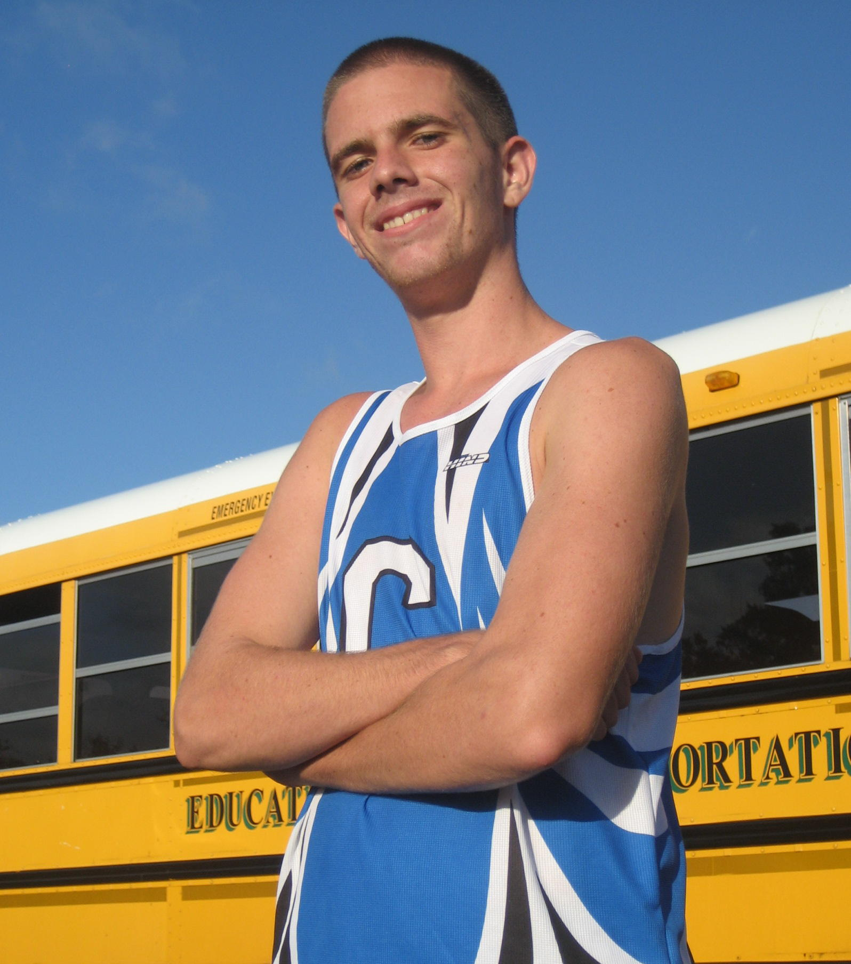

Christopher Urban was in his junior year at Copiague High School when he was suddenly and most unexpectantly taken away from us on October 12, 2010. Unknown to anyone, Chris had a congenital condition known as arteriovenous malformation (AVM) on his brain.

Chris began his running career as a freshman, coming out for the Spring Track team after being cut from baseball. Carrying quite a few extra pounds, Chris was hardly the picture of a “track kid”, let alone a miler. Chris was barely able to break 8 ½ minutes in the mile, running only an 8:18 that freshman season, but to his credit he stuck with it.

Chris came out and ran Cross Country in his sophomore year, still sporting some extra weight but managed to drop time and pounds from the beginning of the season to end, running 27:57 at the beginning and 22:24 at the end. Chris just narrowly missed winning the “MOST IMPROVED” athlete award. He continued running through the winter track season as well, not breaking any records but still working hard every day. Another Spring Track season saw Chris run his best mile yet of 5:45. Sacrifice, dedication, perseverance… these were not just words to Chris, they were a daily ritual.

The summer of 2010, Chris spent many days putting in the mileage for his upcoming junior XC season. Even while on a family vacation to his “family island” in Croatia, Chris ran everyday. He began his XC season right where he left off from his sophomore year, running 22:25. Chris would go on to run a 21:30 for three miles at Sunken Meadow; his best time ever, and just days before his passing. On the morning Chris passed, the team had a XC meet at the Meadow that afternoon. To honor his commitment to the sport and each other, the team decided not to postpone their meet, but instead, race in his name and honor.

That day, Tuesday October 12, 2010, 10 of the 15 varsity runners ran their best time to date,
and won, for Chris.

Brittney Walsh was beautiful young lady, a multi-event track athlete and had just graduated
from Copiague High School on June 22, 2012. She had attended her prom the previous
Thursday. On Sunday evening, June 24th, Brittney was killed by a drunk driver as she
drove home from her part-time job, just blocks away from her home.

Brittney and Christopher Urban were the best of friends.

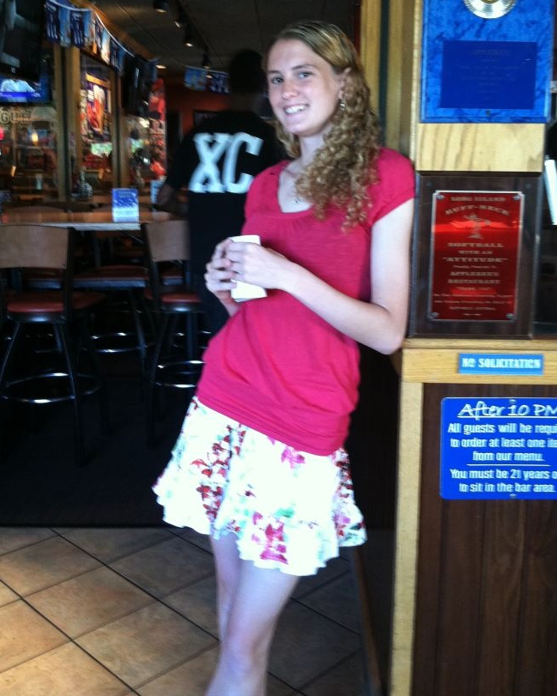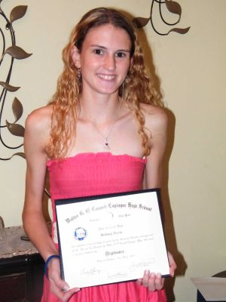
http://www.smile14.org/

Both Brittney and Christopher were my students when they were both juniors. Brittney was an active member and captain on the girls track team, triple jumping and running the 400 and representing her team at the 2012 PENN RELAYS.

Brittney and Chris had a profound and positive effect upon nearly everyone they came in contact with; I wish you could have met them and known them as I had the pleasure and honor of.

Thanks to a very generous donation from Mr.& Mrs. Walsh, the Copiague Track & Field Program now has our very steeple chase barriers, which will forever honor their daughter.

So today, as your athletes compete, remind them of sacrifice, dedication, perseverance, and how each & every one of them can be a winner every single time they compete, through achieving personal bests. That’s what Chris Urban and Brittney Walsh did. Thank you for coming.

Good Luck!
Coach George Schroeder
Chris Urban Memorial Invitational

“Most people run a race to see who is fastest. I run a race to see who has the most guts.”
---Steve Prefontaine

EVENT WINNERS FROM 2011

Boys Girls

10:35.7--- Wes Merriwether- Cop. 2000/3000 Steeplechase not contested

4:40.1--- Wes Merriwether- Cop. 1500/1600

15.80--- Mike Benson- Cop. 110/100 HH

52.50--- Ernesto Medina- Cop. 400

10.9--- Jarrick Ambrose- Cop. 100

2:06--- Rob Prescia- Deer Park 800

58.30--- Zack LeCat- Rocky Point 400IH

23.40--- Davine Clinton- Cop. 200

8:55.2--- Massapequa 4 x 800

3:40.0--- Copiague “A” 4 x 400

not contested TEXAS SPRINT RELAY

43’09.25” --- Darryl Mitchell- Cop. SHOT

168’00”--- Andrew Bylicki- Rocky Point DISC

20’09.25”--- Kevin Vasko- Rocky Point LONG JUMP

41’10”--- Justin Brown- Copiague TRIPLE JUMP

6’04”--- Wade Richardson- Cop. HIGH JUMP

Chris Urban Memorial Invitational

“Most people run a race to see who is fastest. I run a race to see who has the most guts.”
---Steve Prefontaine

EVENT WINNERS FROM 2012

Boys Girls

10:16.7--- Wes Merriwether- Cop. 3000/2000 Steeplechase 8:03---Jen Race---MacArthur

4:41.9--- Corey Slatinitski---Mattituck 1600/1500 not contested

14.2--- Mike Benson- Cop. 110/100 HH 16.8---Small---Amityville

51.5--- Mayan---Center Moriches 400 61.1---Shannon Murphy---MacArthur

11.1---James D’Onofrio---W Babylon 100 12.0---Janel Francis---Copiague

2:03.7---Pat Ducey---MacArthur 800 2:33.8---Weeb---W Babylon

57.4--- Mario Mayen---Center Moriches 400IH 68.3---Destiny MacElroy---Riverhead

22.8--- James D’Onofrio---W Babylon 200 26.0---Ashley Jackson---Copiague

9:42.9---Lindenhurst 4 x 800 not contested

3:33.7--- Copiague “A” 4 x 400 not contested

1:35.4--- Amityville “A” TEXAS SPRINT RELAY 1:51.3---Copiague “A”

48’04.5”---Anthone Stimphel---Riverhead SHOT 31’02.25”---Amanda Seda---MacArthu.

168’00”--- Andrew Bylicki- Deer Park DISC 98’01”---Kerrysha Pittman---Riv.

21’08.5---Alex Williams---Wyandanch LONG JUMP 18’05.25”---Janel Francis---Cop.

44’03”--- Justin Brown- Copiague TRIPLE JUMP 40’02.75”---Meloney Riley---Riv.

6’00”---Dan Geist---Lindenhurst HIGH JUMP 5’00”---Kelly Grossman---Rocky Pt.
Chris Urban Memorial Invitational

“Most people run a race to see who is fastest. I run a race to see who has the most guts.”
---Steve Prefontaine

EVENT WINNERS FROM 2013

Boys Girls

10:43.09--- Juan Taveras- Copiague 3000/2000 Steeplechase 7:04.17---Victoria Ingram---Smithtown W

4:28.87 ---Alex Fitzgerald---Ward Melville 1600/1500 5:03.16---Mackenzie Coleman---Sachem N

:15.29--- Aaron McFadden---Copiague 110/100 HH :15.59---Nikki Fogarty---Sachem N

:51.14---Conner Christian--- Ward Melville 400 :59.69---Jessica Gonzales---HHHW

:11.08---Jarried Redwood---HHW 100 :12.62---Alyssa Leto---Sachem N

1:58.87---Jake Burcham---HHHE 800 2:31.19---Kristina Schrepf---Sachem N

:55.10---Tobias Nelson---Brentwood 400IH :66,82---Kaitlin MacDonald---Rocky Point

:22.56----Maleik Henry--- HHHE 200 :26.63---Kayla Hodge---HHHW

8:49.63---Ward Melville 4 x 800 10:44.36---HHHW
(R. Fan, T. Francisco, J.P. Humpreys, C. Theiss) (V. Sacchetti, E. Pabisch, M. Iris, O. Sabatino)

3:27.19--- HHHW “A” 4 x 400 4:34.93---Sachem North
(B. Johnson, J. Connor, H. Thaper, J. Blackman) (E. Lin, M. Abrams, T. Buechner, G. Czerw)

1:37.50--- Brentwood “A” TEXAS SPRINT RELAY 1:57.71---Copiague “A”
(D. Kidd, D. Smith, N. Ortiz, T. Nelson) (J. Ruiz, A. Jackson, A. Arquer, N. Austin)

54-02 ---Ben Bonhurst--- Smithtown W SHOT 37-00.75 ---Tiara Davis---HHHW

164-02 ---Ben Bonhurst--- Smithtown W DISC 103-01 ---Tiara Davis---HHHW

21’02.75---Zachary Acocella---E Islip LONG JUMP 16-10.5 ---Sunja Joseph---Sachem N

not contested TRIPLE JUMP not contested

6-04 ---Maurice Epps---Copiague HIGH JUMP 5-02 ---Carly Swinford---Sachem N

14-00 --- Jonah Spaeth--- Riverhead Pole Vault not contested
--- Dan Normoyle---Riverhead

Chris Urban Memorial Invitational

“Most people run a race to see who is fastest. I run a race to see who has the most guts.”
---Steve Prefontaine

EVENT RECORDS

Boys Girls

10:16.7--- Wes Merriwether- Copiague “12 3000/2000 Steeple 7:04.17---Victoria Ingram---Smithtown W “13

4:28.87 ---Alex Fitzgerald---Ward Melville ‘13 1600/1500 5:03.16---Mackenzie Coleman---Sachem N “13

:14.24---Mike Benson---Copiague ‘12 110/100 HH :15.59---Nikki Fogarty---Sachem N “13

:51.14---Conner Christian--- Ward Melville “13 400 :59.69---Jessica Gonzales---HHHW “13

:11.08---Jarried Redwood---HHW “13 100 :12.24---Janel Francis---Copiague “12

1:58.87---Jake Burcham---HHHE “13 800 2:31.19---Kristina Schrepf---Sachem N “13

:55.10---Tobias Nelson---Brentwood “13 400IH :66,82---Kaitlin MacDonald---Rocky Point “13

:22.56----Maleik Henry--- HHHE “13 200 :26.24---Ashley Jackson---Copiague “12

8:49.63---Ward Melville “13 4 x 800 10:44.36---HHHW “13
(R. Fan, T. Francisco, J.P. Humpreys, C. Theiss) (V. Sacchetti, E. Pabisch, M. Iris, O. Sabatino)

3:27.19--- HHHW “A” “13 4 x 400 4:34.93---Sachem North “13
(B. Johnson, J. Connor, H. Thaper, J. Blackman) (E. Lin, M. Abrams, T. Buechner, G. Czerw)

1:35.4--- Amityville “A”- 2012 TEXAS SPRINT RELAY 1:51.54---Copiague “A” “12

54-02 ---Ben Bonhurst--- Smithtown W “13 SHOT 37-00.75 ---Tiara Davis---HHHW “13

164-02 ---Ben Bonhurst--- Smithtown W “13 DISC 103-01 ---Tiara Davis---HHHW “13

21’08.5---Alex Williams---Wyandanch- “12 LONG JUMP 18-05.25---Janel Francis---Copiague “12

44-03----Justin Brown---Copiague “12 TRIPLE JUMP 40’02.75”---Meloney Riley---Riv. “12

6-04 ---Maurice Epps---Copiague “13 HIGH JUMP 5-02 ---Carly Swinford---Sachem N “13
---Wade Richardson---Copiague “11

14-00 --- Jonah Spaeth--- Riverhead “13 Pole Vault not contested
--- Dan Normoyle---Riverhead “13

